Differentiation is a rate of change of y as x changes, where changes in x tends to 0.

We can also say that dy/dx = tan theta.

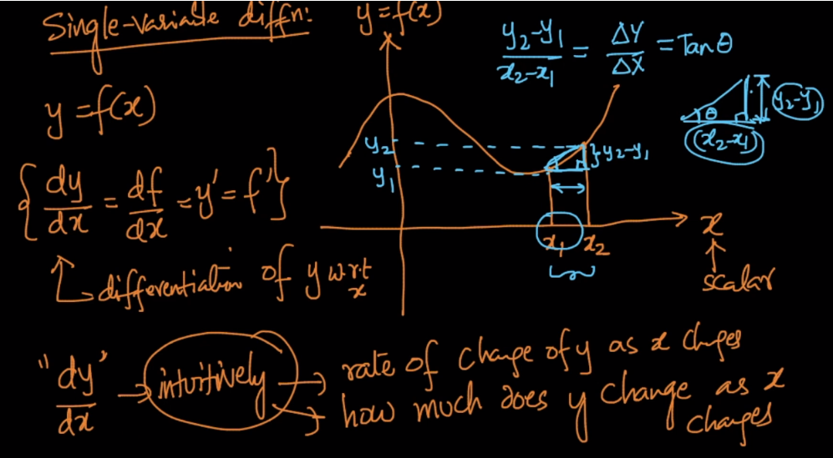

As changes in x tends to 0, we get a point, a there will be a tangent passing through this point which is slope or tangent. This tangent is basically extend till x axis

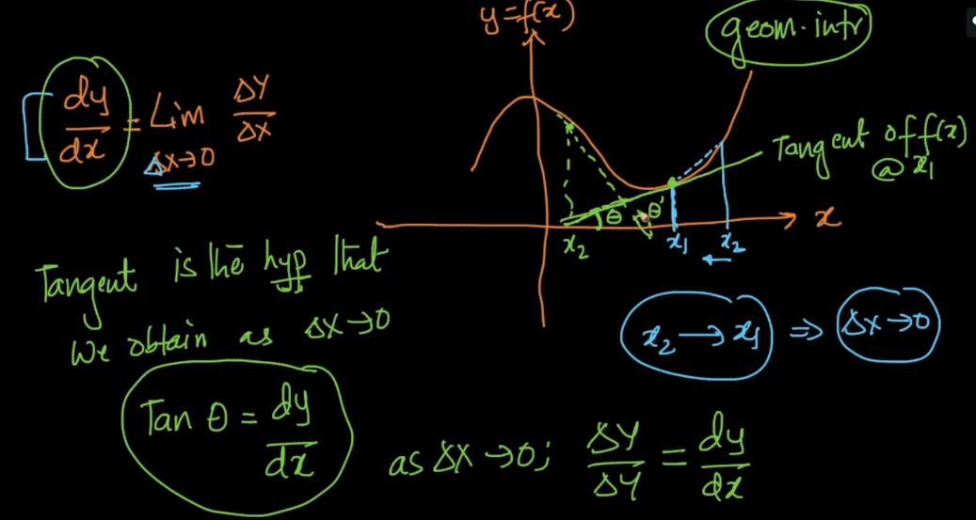

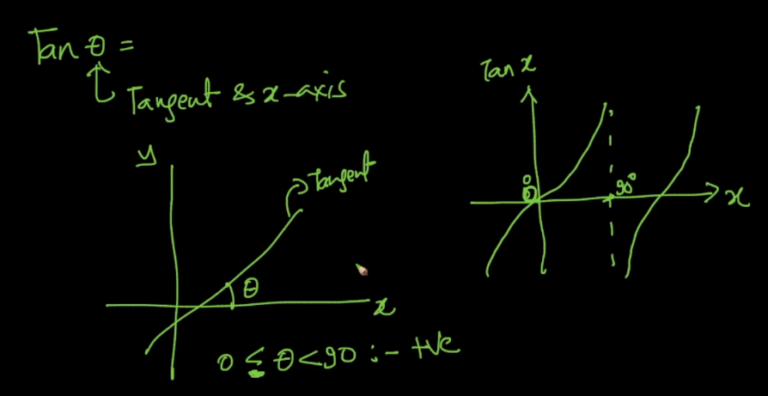

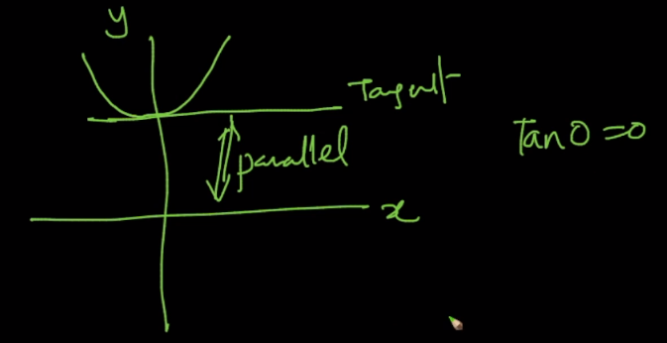

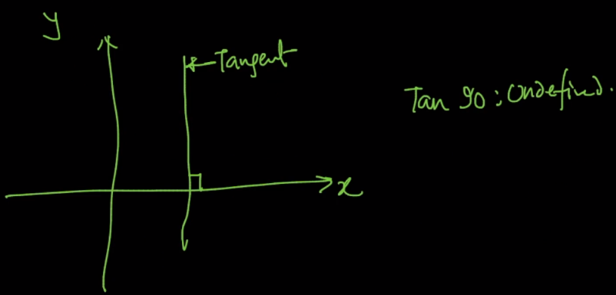

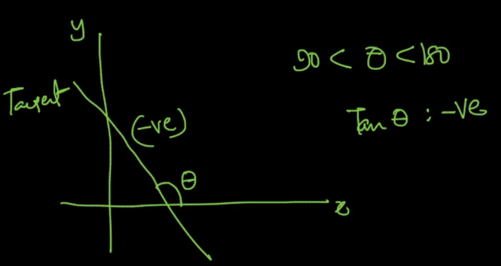

Below image shows when slope will be +ve and when it will be -ve.

Since tan is +Ve for 0 <= theta <= 90 and -ve if theta > 90.

Therefore if we extend the tangent will get following slopes.

